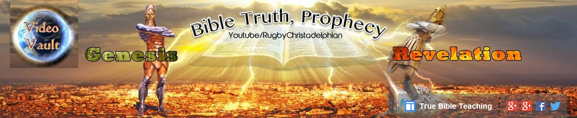
Introducing the Bible Truth Prophecy Video Vault. and the Christadelphian Video YouTube Channel’s
https://www.youtube.com/user/RugbyChristadelphian
https://www.youtube.com/user/ChristadelphianVideo
Link to Videos of these talks
https://www.youtube.com/playlist?list=PLsmUZDApxHVFm0z2j9iZ33e83DLneKKXa
What is it?
The B.T.P.V.V is the Christadelphian YouTube channel that features high definition (HD) videos with PCM quality audio sound (the majority of our videos are recorded or converted to HD 1080p and 96kHz /24 bit PCM audio and are suitable for Projection onto large screen or TV and ideal for burning to DVD.)
This channel’s main objective is for the purpose of Preaching Gods plan and purpose for this Earth and mankind upon it to those who will are willing to listen. “Go ye therefore, and teach all nations, baptizing them in the name of the Father, and of the Son, and of the Holy Ghost:” Matt 28:19
The channel also offers a large amount of video material for the brotherhood that would otherwise not normally be seen due to time and distance constraints.
We also have a member’s only area where we store exhortation video recordings.
The hyperlinks to these recordings are then sent out to Brethren and Sisters all over the globe. If you would like to receive them please e-mail christadelphianexhortations@gmail.com advising which ecclesia you attend and which fellowship you are associated with.

Please browse our back catalogue to find a subject title that you might find interesting.
We have Bible classes, seminars, fraternal gatherings and Bible schools, also included are many more videos that have been produced especially for the channel.
We also have included many videos of prophecy days held here in the UK and other from across the world.
All our videos are placed in easily searchable ‘themed playlists’
Bible Truth & Prophecy is a remarkable on-line tool for establishing just how far removed from the teachings of the Bible mainstream Christian teaching has become.
End Time Prophecies are accurately interpreted using the Bible not man made ideas or notions.
Key Biblical subjects such as the Trinity, Devil/Satan worship, Holy Spirit Gifts & much more are all dealt with extensively from the Bible's view point and not man's.
We will demonstrate how Christian beliefs have become corrupted, and reveal the 'Truth' as taught by the 1st Century Apostles and the prophets of old.

